OFI WG Weekly telecom – 03/31/2015

Agenda:
- Release Readiness – are we at rel 1.0 rc3?
- Adding maintainers to fabtests
- Complete the Completion discussion

Release Readiness – ready for release 1.0 RC3
- USnic still needs to update its man pages.
- other man pages likely also need to be updated.
- there are also a set of changes to the API that need to go in.
- Saw errors over the weekend from the current top of the tree – verbs provider working, but sockets providers still hurting.
- plan is to post a new tarball before midnight (Cisco needs this to meet an internal waiver that expires at midnight).
- Need to update the build to indicate rc3 and build the tarball.
- Jeff had created skeleton man pages for all providers, but they may not all have been filled in by rc3 time.

Add new maintainers for fabtests
- today, there are only ~two organizations with write permissions. Should we expand that list.
- libfabrics already does this today, it has multiple writers
- Agreed to add new writers – Howard P., Dave Goodell

Completions Topic
Reviewed Bernard’s use case table for remote completion semantics. This table was discussed at length at this week’s DS/DA meeting (previous hour).

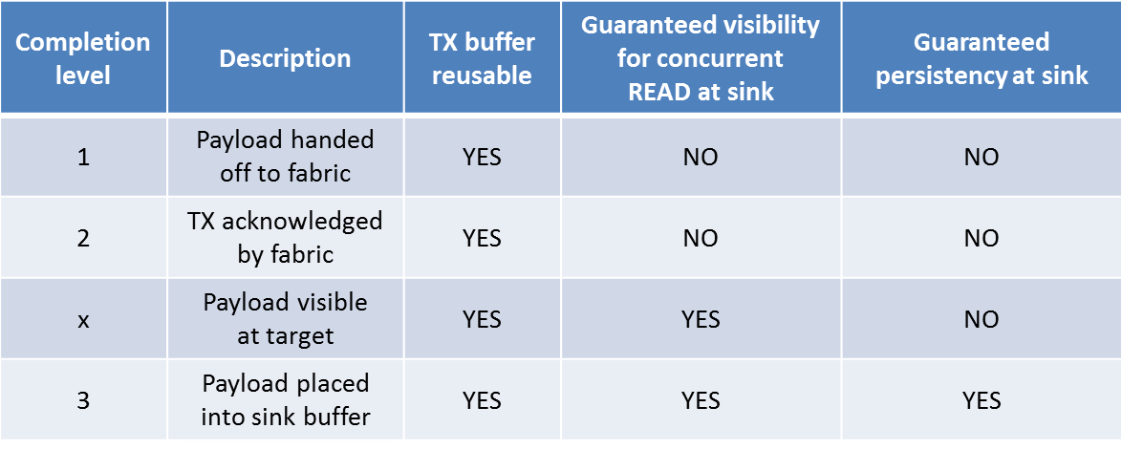

An important distinction between level ‘x’ and level ‘3’ is that the major consumer of the completion notification in level ‘3’ is the requester since this allows the requester to release his local resources.

- Storage usage model: a file is updated on the remote side using a series of RDMA write operations. At the conclusion of the writes, the requester wants to atomically update the tree structure reflecting the newly updated file. This can be accomplished using an optimized cache flush operation, and having the acknowledgment of the flush be delayed until the relevant sections of the cache have been flushed to persistent memory. This allows the requester to receive a single notification that all the relevant data has been pushed to persistent memory.

- byte addressable memory operations, SHMEM: each of these might benefit from receiving an immediate notification that the write operation to persistent memory has completed. This is case #3 in Bernard’s use case table. For byte addressable memory operations, it is considered an optimization to be able to distinguish between writes to volatile memory.

-MPI: today, classical two sided MPI operations use completion levels 1 (local completion) or 2 (remote completion). One-sided operations today exchange an additional handshake notifying the requester that the message has been received. It is felt that one-sided operations would benefit from completion level ‘x’ (i.e. the requester is notified via a completion event that the message has been committed to memory on the responder side and is accessible to the consumer).

Currently, levels 1 & 2 are implemented and documented in the man pages. There is a placeholder in the man pages for level 3, but that will be removed until we can complete the discussion.

Webex link: https://cisco.webex.com/ciscosales/j.php?MTID=m9389b0513c9ae643d57e2381e254dcf5
Webex password: ofi

Future Agenda Topics:
- Interfaces and structures for reporting topology data
- Technical issues
  - AV table insert/remove behavior

OFIWG Download Site: www.openfabrics.org/downloads/OFIWG
Github: https://github.com/ofiwg/libfabric
OFI Software Download Site: www.openfabrics.org/downloads/OFI

Link to WebEx Recording

Next regular telecon
Next meeting: Tuesday, 4/7/15
9am-10am Pacific daylight time

