Proposed OFA libfabric API extensions to add native RDMA support for persistent memory

Primary Author: Chet Douglas (chet.r.douglas@intel.com)
Organization: DCG Crystal Ridge SW Architecture
Date: 07-19-2016
Version: V0.63
Table of Contents
1 Document Revision History 2
2 Document Overview 3
1. libfabric API 3
3 Motivations for this proposal 4
4 OFA High-Level Software Interfaces 5
1. Proposed libfabric Interface extensions for PMEM 5
4.1.1 fi_getinfo 5
4.1.2 fi_mr_reg 6
4.1.3 fi_writemsg Updates 7
4.1.4 fi_writemsg ordering and completion semantics with PMEM 8
4.1.5 Sample Use Cases 9
5 Software API & Architecture Opens 13
6 Document Opens 15

Table of Figures
Figure 1- Current libfabric API usage with PMEM 9
Figure 2- Proposed libfabric extension usage with PMEM 10
Figure 3- Proposed libfabric extension usage with PMEM 12

Document Revision History
Version | Document Changes
V0.60 05/11/16 | -Initial document with updates for internal Intel libfabric interface reviews  -Added open issues section to track additional work for this proposal
V0.61 05/19/16 | -Updates from the SNIA NVM TWG review  -Fixed use case pictures and added missing cases  -Updates to open architecture section with NVM TWG review feedback added
V0.62 06/07/16 | -Added open architecture section consideration to create new fi_* API instead of overloading fi_writemsg with FI_COMMIT and FI_IMMED  -Moved opens section to the end of the doc  -Updates from latest SNIA review & discussion  -Updates to open section from first OFA DSDA open discussion
V0.63 07/19/16 | -Removed FI_NON_STANDARD_MEMORY_DEVICE support in fi_mr_reg API  -Updates with the latest OFI DSDA Feedback and opens (see “TODO” labels through-out spec)

Document Overview
This document describes proposed Open Fabric Alliance (OFA) SW API extensions/modifications to support native accesses utilizing remote byte addressable persistent memory. The scope is limited to the OFA libfabric and libibverb network access application libraries. This document only describes the changes related to adding remote persistent memory support and does not document all of the current interfaces that are not related to these changes.

libfabric API
libfabric API is a Linux ring3 application common network fabric API that is being introduced in to the Linux community and is governed by the OFA OFIWG. A kernel version of the API is also being worked on and is governed by OFA DSDA WG. Behind the API is a set of libfabric providers that implement the API for each fabric technology. In the picture below a verbs provider implements the libfabric API and provides a thin layer to the existing libibverbs library. This provides libfabric API linkage to RoCE, IB, and iWARP based fabrics.

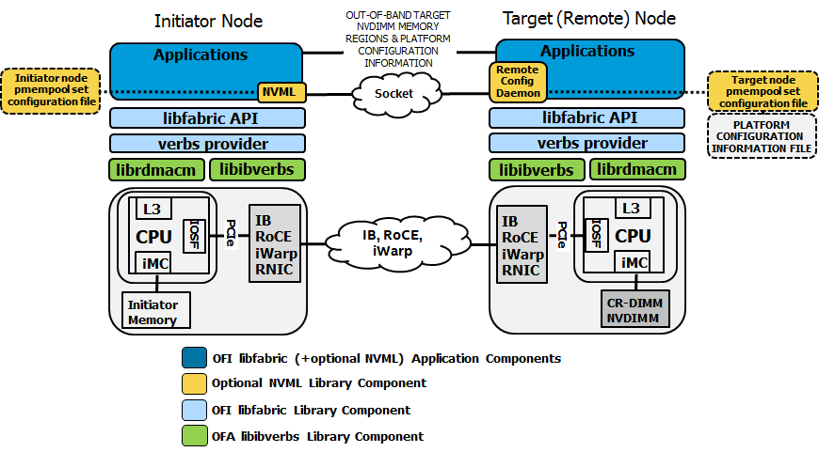

Motivations for this proposal
- This proposal is primarily driven by a detailed Intel HW assessment of the RDMA IO paths and an understanding of how the Intel chipset architecture currently works
- The motivation for these SW API extensions is to increase bandwidth and obtain the lowest possible latency with the lowest HW design complexity and reflects Intel’s current thinking on how we might implement native pmem support for RDMA
- We have talked to a significant number of ISVs and OSVs to try and understand the most common Use Cases from an application perspective and have incorporated the feedback in to this proposal
- There are a number of open architecture questions in the proposed API extensions where we need more detailed feedback and more detailed understanding of application Use Cases
- The main goal of publicizing this SW API proposal now is to start an open discussion & dialog across the industry with the goal to eventually end with a set of standardized OFA API Extensions to provide native RDMA support with pmem

OFA High-Level Software Interfaces

Proposed libfabric Interface extensions for PMEM
The following sections describe the proposed modifications and extension to the Linux libfabric Interface Extensions.

fi_getinfo
-Retrieve information about each fabric endpoint for a given connection
-Capabilities expanded to describe byte addressable persistent memory support for each endpoint
int fi_getinfo( int version,
const char *node,
const char *service,
uint64_t flags,
struct fi_info *hints,
struct fi_info **info);
Add the following capability bit to the info flags field to describe additional capabilities of the system. The caller requests specific capabilities to be supported in the info struct and the endpoint SW will update the same info struct with the supported capabilities:
- FI_PMEM
  - Initiator or target node is capable of supporting byte addressable persistent memory (Pmem). Assumes endpoint supports read/write to pmem with additional write flags utilized in fi_writemsg and additional access flags utilized in fi_mr_reg.
  - Endpoints that only support a single read or write direction to pmem can optional set the FI_READ, FI_READ_REMOTE, or FI_WRITE, FI_WRITE_REMOTE flags with FI_PMEM to report specific direction supported.
Alter the following to the current flags definitions:
- FI_RMA_EVENT : Requests that an endpoint support the generation of completion events when it is the target of an RMA and/or atomic operation. If set, the provider will support both completion queue and counter events. This flag requires that FI_REMOTE_READ and/or FI_REMOTE_WRITE and/or FI_PMEM be enabled on the endpoint.

fi_mr_reg
-Register persistent memory data buffer addresses with the fabric controller for a specific protection domain with requested accesses and return the lkey and rkey handles that describe the registered memory
TODO: Tweak the language to reflect the current use of keys..
-Access attributes expanded to include new memory and device types
-By making these part of opaque rkey, initiator SW is not burdened with understanding these attributes
int fi_mr_reg( struct fid_domain * domain,
const void * buf,
size_t len,
uint64_t access,
uint64_t offset,
uint64_t requested_key,
uint64_t flags,
struct fid_mr ** mr,
void * context);
Add the following bits to the flags field to further describe the attributes of the memory region being registered. The access requested is a combination of OR’ing these new access capabilities with existing flags:
- FI_PMEM – Memory region being registered is byte addressable persistent memory
- FI_UNCACHED - Memory region should not be backed by cache. When data is written to this region, the local cpu caches should be bypassed. Without this flag being present, the write data should be placed in cpu cache as SW will most likely access the data shortly after remote transfer is complete.

fi_writemsg Updates
-The existing fi_writemsg API is utilized for writing to persistent memory
-When this command is utilized with the FI_COMMIT flag, this command has the completion semantics of an fi_read and will not return a completion to the initiator until all data within scope of the command has been committed to the durable memory domain.
-The write with commit allows previous write data to be attached to the command. Previous calls to fi_write* utilizing the same QP and same RKEY value will be within scope of this write with commit and will also be committed to the durable memory domain before the completion is signaled.
-The existing libfabric mechanism for setting up a CQ is utilized to set up and register an initiator SW completion queue and notification for writes with commit.
static inline ssize_t fi_writemsg( struct fid_ep *ep,
const struct fi_msg_rma *msg,
uint64_t flags)

struct fi_msg_rma {
const struct iovec *msg_iov;
void **desc;
size_t iov_count;
fi_addr_t addr;
const struct fi_rma_iov *rma_iov;
size_t rma_iov_count;
void *context;
uint64_t data;
};
The following libfabric flags are added for handling writes to persistent memory. The flags are utilized by the target node endpoint device to precisely control steering of the write data and handling of any device specific completion handling. Therefore these indicators should be visible in the wire protocol payload and available at the target end point:
FI_COMMIT – Commit to pmem all data within scope of the command. Completion to the initiator occurs after all data has been committed to the durable memory domain. Previous fi_write* messages sent to the same rkey on the same will also be committed to durability before the completion is signaled.
-With a non-volatile memory region (memory registered with FI_PMEM), completion indicates all write data in scope has reached durability and is power fail safe. Once durability occurs the Initiator RNIC will insert a Completion WQE on the initiators CQ to notify SW.
-With a memory region that is volatile memory (memory registered without FI_PMEM). The completion indicates all write data in scope has reached the global visibility point
FI_IMMED – Used in conjunction with FI_COMMIT – Once all write data in scope of the write has reached the pmem durability domain issue a Completion WQE to the target CQ. Setting this flag without setting FI_COMMIT is considered an error.
FI_FENCE – Extend the use of this existing flag to cover fencing of writes on the target node. When set with FI_COMMIT, the target endpoint will guarantee that previous writes with the same RKEY will be made durable before executing this fenced write to the same RKEY.

fi_writemsg ordering and completion semantics with PMEM
Here are the basic rules for using the fi_write* API with persistent memory:
- All existing libfabric fi_write* API can be utilized to write data to PMEM by supplying an RKEY whose memory region was registered with FI_PMEM set
- fi_write, fi_writev, fi_writedata, fi_inject_write and fi_inject_writedata API that do not take a flag argument cannot request data to be committed to the persistent memory durable domain
- For fi_writemsg (with FI_COMMIT set) to properly commit other write data previously sent via fi_write* API methods, all of the commands must utilize the same QP for all command submittals and must utilize the same RKEY.
- There is no write data ordering guarantee for any sequence of fi_write* or fi_writemsg commands sent to different QPs or different RKEYs.
- The ordering of write data associated with fi_writemsg (with FI_COMMIT set) with respect to the ordering of write data for other fi_writemsg (with FI_COMMIT set) requests is indeterminate, even when issued on the same QP and RKEY. It is possible for one to pass the other. SW must utilize the FI_FENCE with FI_COMMIT to avoid this indeterminate ordering on the same RKEY.
- To control write data placement ordering on the same QP but to different RKEYs, SW can continue to utilize fi_read* or fi_send* API in between fi_writemsg (with FI_COMMIT set) commands.

Sample Use Cases

Existing libfabric API being used with PMEM
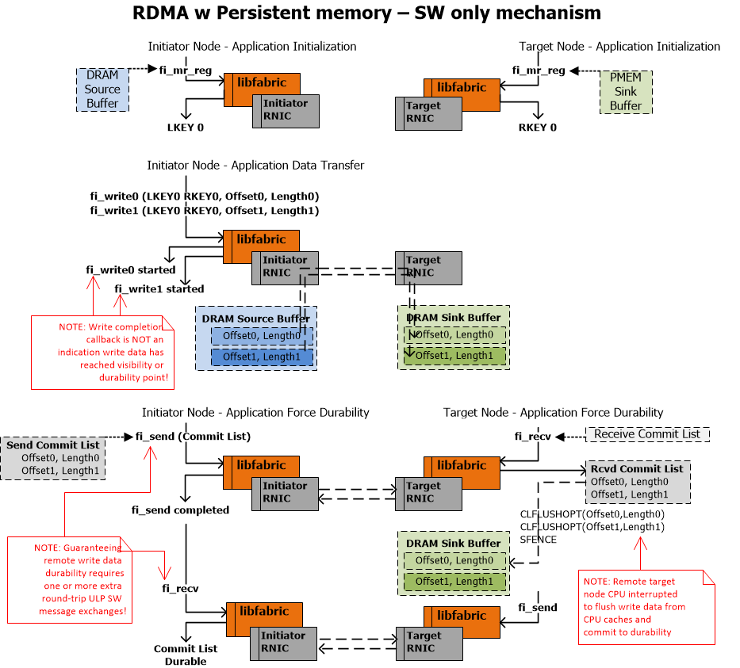
Figure 1- Current libfabric API usage with PMEM

Proposed libfabic API extensions being used with PMEM
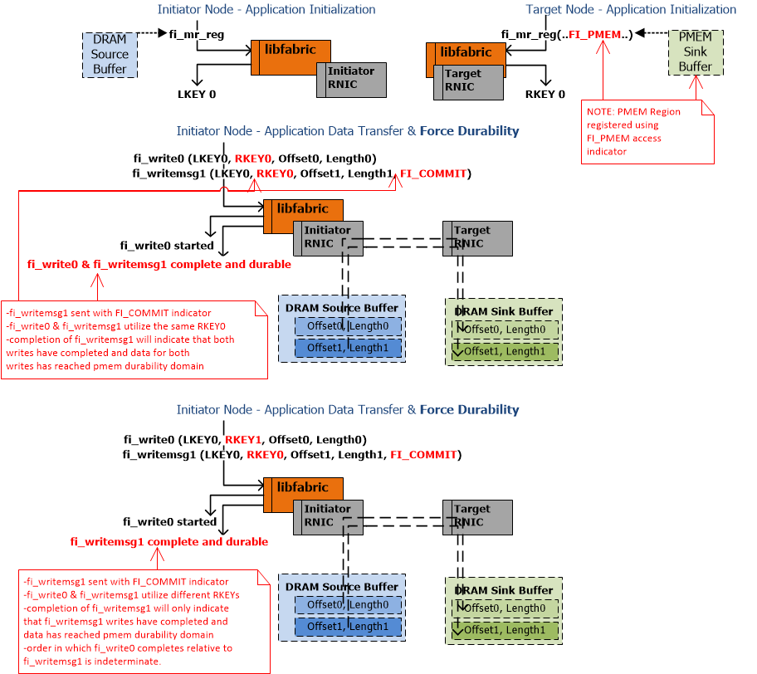
Figure 2- Proposed libfabric extension usage with PMEM
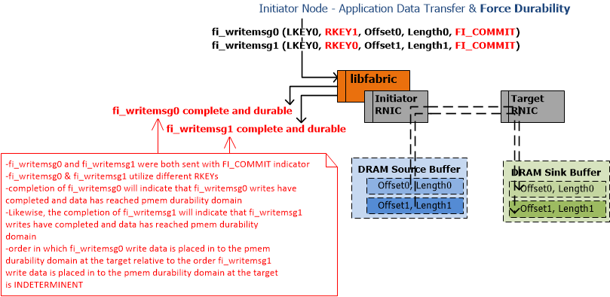

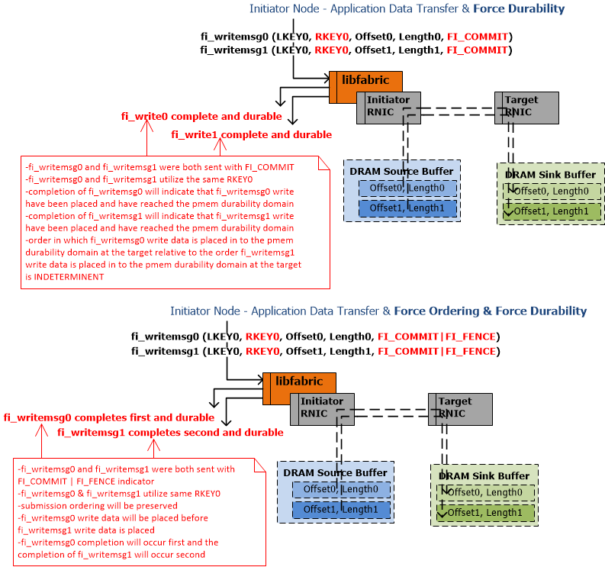
Figure 3- Proposed libfabric extension usage with PMEM

Software API & Architecture Opens
This section outlines the open architecture issues effecting the proposed OFA libfabric API:
- Fencing of Write Commit
  - FENCE IMPLEMENTATION: This proposed implementation allows optional strict target node write data placement ordering to be imposed at the initiator for the current write relative to previous writes as long as the writes are all issued on the same QP and RKEY. However, subsequent writes can pass previous writes and current write
  - BARRIER IMPLEMENTATION: Do we need to consider controlling ordering of the current write with respect to previous writes AND subsequent future writes? This is not currently in our proposal as it forces in-order data placement which is a complexity that we would like to avoid.
    - SNIA NVM TWG Feedback: The current SNIA Programming model implies that applications won’t issue any more writes to a QP/RKEY until the outstanding commit has completed. This means that there won’t be subsequent future writes outstanding when a commit is sent. If SNIA decides to take add multiple sessions/threads to the programming model, then these details would need to be considered.
    - OFI: Fence impacts future writes as well so go ahead and specify that, independent of inclusion in the programming model. What happens before the fence arrives? Until the fence command is on the wire previous write must be considered previous writes. TODO: Revisit later once Use Cases are reviewed.
    - OFI: Existing FENCE semantics typically provide full barrier semantics – Contrary to IB but on a QP basis - Depends on Use Case being solved – TODO: Revisit later once Use Cases are reviewed.
  - Should we utilize an indicator to allow SW to dynamically apply commit scope to QP with or without RKEY? Fencing could be applied to all RKEYs on the same QP. This is an area that will need further discussion.
    - With QP scope (single home) with multiple devices (some writes going to memory, some to MAD device) – should/can the single ordering point still be the CPU/IIO complex?
    - With the current implementation, SW can utilize fi_send* or fi_read* fencing to control ordering of writes to different RKEYs – today depends on WAW on per end point basis. TODO: Update doc throughout to explain the current mechanism and that it is preserved in the new API proposal
    - SNIA NVM TWG Feedback: We should consider fencing of all rkeys on the same QP.
    - OFI: TODO: Probably need to consider this
- Allocating SQ, RQ, and CQ from PMEM
  - Not addressed in this proposal but there are probably additional complications for recovery and cleanup after power fail if these queues are utilizing pmem
  - SNIA NVM TWG Feedback: Don’t allow QPs to be allocated from pmem is a reasonable limitation
- fi_mr_reg
  - FI_UNCACHED hint - OFA DS/DA Feedback: Consider cache/noncache hint be made available to initiator application. TODO: Revisit this ask one SW Use Cases have been reviewed & gather OSV feedback on whether this indicator should be exposed to the initiator sw. This would require this bit to be put on the wire as part of the fabric extensions.
- Overloading fi_writemsg
  - By adding FI_COMMIT and FI_IMMED to existing fi_writemsg API, it makes it look like we are asking for changes to existing fabric write protocol to add new indicators, which is not the proposal
  - The intent of the proposal is that both these flags would be treated as new fabric opcodes and would NOT affect existing fabric write proposal.
    - fi_writemsg with FI_COMMIT would be a new unique opcode on the fabric
    - fi_writemsg with FI_COMMIT and FI_IMMED would be a new unique opcode on the fabric
  - TODO: Current plan is to stick to the overloading of fi_writemsg API
- Atomicity guarantees
  - Consider additional libfabric interfaces for programmatically determining the maximum supported platform atomicity “chunk”. This needs to comprehend the atomicity of each HW component in the data path.
  - Could spec the 8 byte guarantee as part of the fi_writemsg with FI_COMMIT but if it changes it is more extensible to make this a SW discoverable attribute of the endpoint in the connection.
Here is a table of the most obvious architectural differences between this proposal and other SNIA driven interfaces:
Highlighted differences between proposals | Intel libfabric SW API proposal | Public SNIA HA White Paper | Tom Talpey’s Public IETF Draft Proposal
Scope of write data to make durable | -Writes preceding the write with commit and the write commit data are all in the scope of write data to be made durable when sent to the same RKEY representing a pmem registered memory region on same QP  Single Region per WriteCommit + prior writes for other ranges to same region | -An explicit list of data regions defines the scope of write data to make durable proposed in the “OptimizedFlush” payload. Preceding writes are required to move the data contained in the commit list.  -QP or RKEY limitation is specified (implied)  List of Ranges or Regions to Commit | -An explicit SG list of data regions defines the scope of write data to make durable in the “RDMA Commit” payload  -Preceding writes are required to move the data contained in the commit list  -The commit list is the minimum data that must be made persistent and other data written to persistent memory may be committed at any time  List of Ranges or Regions to Commit
Controlling write data placement ordering at the target | -All writes requiring strict data durability ordering require use of commit & fence flag in separate write requests when sent to the same RKEY representing a pmem registered memory region on same QP | -Ordering implied by optimized flush semantics | -Single RDMA Commit operation provides optional 64bit write data to be made durable only after explicit list of data regions have been made durable  See open architecture notes above about atomicity guarantees.

Document Opens
Areas of the documentation that need to be addressed or cleaned up:
- QP – TODO: Remove and replace with “Connected Endpoint” throughout document
- Fencing: TODO:Properly document existing libfabric API ordering mechanisms using RAR, WAW, RAW, WAR and update extensions as needed
- FI_IMMED – TODO: Make it clear that we are intending for the same existing IMMED functionality is preserved. Make it clear what is delivered to the Target node SW. A small amount of context that SW can utilize as an indicator of what writes were now persistent. The write data itself is NOT provided to the Target Node SW, only a small context buffer.
- 4.1.4, Bullet 5 – “The ordering of write data associated with fi_writemsg (with FI_COMMIT set) with respect to the ordering of write data for other fi_writemsg (with FI_COMMIT set) requests is indeterminate, even when issued on the same QP and RKEY. It is possible for one to pass the other. SW must utilize the FI_FENCE with FI_COMMIT to avoid this indeterminate ordering on the same RKEY. ” – TODO: Consider rewording this – it’s the fence flag that controls the ordering – currently flags can be used to force fencing today - _WAW, _RAW, _WAR, _RAR

